BRINGING THE SQL TABLE TO POWER BI:
Get Data > More > SQL Server Database
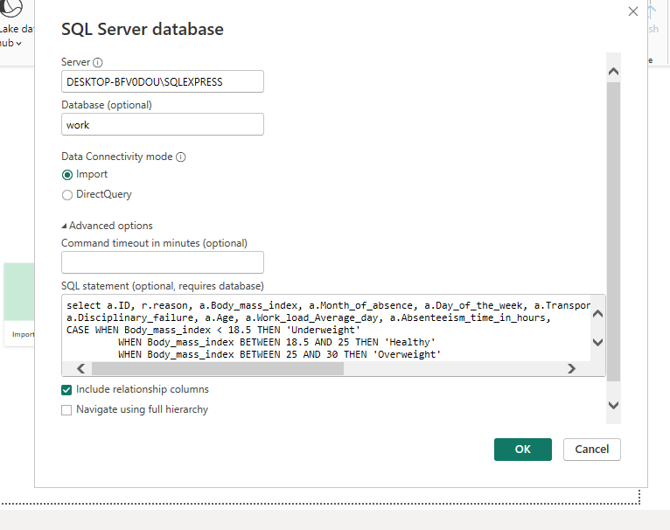
+ OK + Load

